**Angular Acceleration of a Hard Disk Drive Platter, Tristan Morse, Inquire Page # 3**

**Description of Observation**

For some time now, I’ve been trying to get really into technology, especially with computers regarding their software and hardware. Because of this interest, I naturally felt the inclination to major in computer science and minor in new media at UNC Asheville. Since I’m going to be delving deeper into this field, I wanted to learn more about what I don’t know too much about: the hardware side of computers. This summer, I will be making a custom PC to use throughout college and beyond, as I will upgrade it as the years go on. Besides having to figure out how to assemble it all, I was actually wondering about some specific aspects of some of the parts in relation to physics. More specifically, I’m going to be installing a couple “hard disk drives” or “HDD’s,” as shown in figure 1, which are parts that the computer stores information onto magnetically, retaining the information even after someone where to turn off their computer. There are usually several metal disks inside, giving it its name, which are known as “platters” which are spun around at a certain RPM by the “spindle.” The disks are manipulated by the “heads” on the “actuator arms,” which are controlled by the “actuator.” The head uses magnetic currents to encode binary signals, creating the storage of data values that the computer understands. With a HDD, I was wondering what its angular acceleration would be in a certain time interval of about 3.0 seconds.

**Visual**

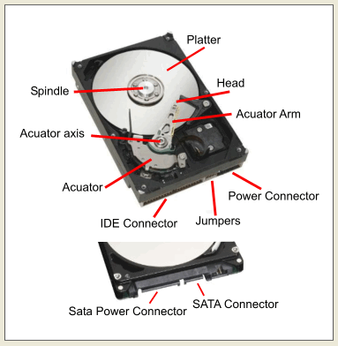

*Figure 1: The internals of a Hard Disk Drive (*<https://goo.gl/WVqU1X>*)*

**Physics Principles at Work**

A few physics principles at work in this observation are:

* Rotational Kinematics

**Inquire**

What is the angular acceleration of one of the platters in my hard disk drive in the time interval of 3.0 seconds?

**Assumptions and Data Required**

Assumptions:

* Hard disk drive is in good condition
* No faults in rotational motor
* Nothing snags or catches on the platter
* Required voltage is supplied

Data Required

* RPM of platters